Make you Own Moby

Lesson Sequence
Key Concept / Learning Objective | Activities | Resources/Room Design |  | Assessment
Make you own Moby  Suggested timeframe: 2-3 lessons | Summary: This lesson sequence will offer students an opportunity to explore the concept of 3D printing its various applications. After viewing a video students will be asked to answer questions about 3D printing, create a simple design that can be 3D printed and print a 3D object (optional depending on availability of 3D printers).  The conteht for this series of lessons is based on the BrainPop module on 3D printing.
Curriculum Content Covered:
KNOWLEDGE & UNDERSTANDING: Digital Systems > Digital systems have components with basic functions that may connect together to form networks which transmit data
PROCESSES PRODUCTION & SKILLS: Creating Solutions by: Investigating and Defining > Define a problem, and set of sequenced steps, with users making a decision to create a solution for a given task, Identify available resources. Producing and implementing > Select, and apply safe, procedures when using components and equipment to make solutions
GENERAL CAPABILITIES/CROSS CURRICULUM PRIORITIES: Critical and Creative Thinking, Information & Communication Technology
Students will:  - Identify what 3D printers currently can and cannot print.  - Explain how 3D printer technology works.  - Sketch a useful object that could be made using current 3D printer technology. | Lesson Plans  3D Printing Lesson Plan: Make Your Own Moby  Grade Levels: 3-5, 6-8,  In this lesson, which is adaptable for grades 3-8, students use BrainPOP resources to explore 3D printing. Students will learn what 3D printers can and cannot do and sketch a useful object that they’d like to make with a 3D printer. Students with 3D printer access will also be able to print their own 3D Moby.  Lesson Procedure:  - Immersion  Teacher-directed: Provide a range of 3D objects, articles, images and videos for students to explore OR  Student-directed – have students bring along to class one piece of information, image, idea or example of 3D printing.  - KWL Chart  Explain to students that they will complete a KWL Chart about what they know and what they want to find out about 3D printers.  In groups have students explore the resources and complete columns 1 and 2 of the KWL Graphic Organiser (individually or in groups) OR they can contribute to a shared KWL Chart in Google Docs.  Display the shared Graphic Organiser on a digital screen so students can see what is being added. Type their responses into the organiser (or students add it to the Google Doc themselves.  - Viewing  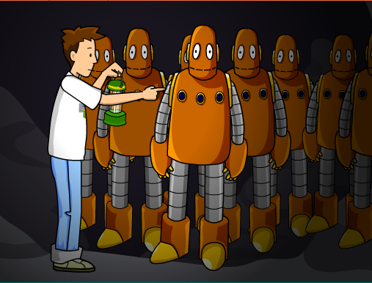  Play the 3D Printing Movie for the class.  Return to the Graphic Organiser.  - Is there any information they thought they knew that was incorrect?  - What new information do they have now?  - Which questions were answered and which remain unanswered? Are there any new questions that students have?  - Modify the KWL as required  - Printing 3D Object from File (optional)  If you have access to a 3D printer in your classroom, tell students they will have the opportunity to print their own 3D Moby, just like in the movie. Show students what the 3D Moby .stl file and printer look like and demonstrate how to print.  - Design 3D Object – Basic Sketch  - Pass out copies of the Activity or graph paper, and encourage students to sketch something that is both useful and simple enough to print on a 3D printer.  - Allow students to share their ideas and creations with the class. Suggest that when they begin using Design programs in later lessons that they will be able to use this model as a start.  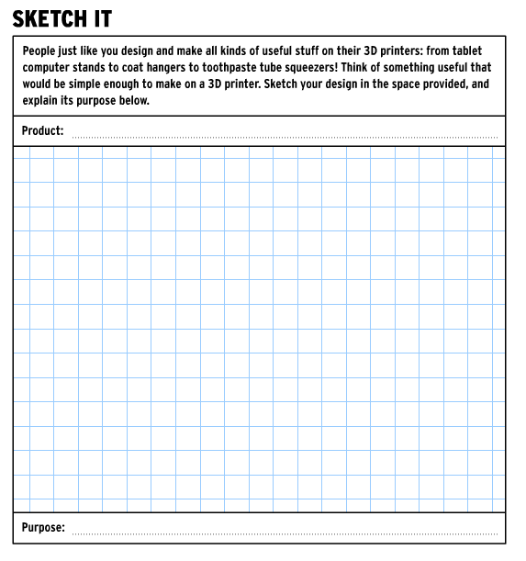  - Quiz  You can assess student learning using the Quiz.  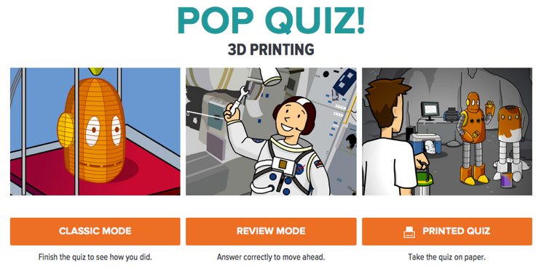  Suggested Extension Activities:  - Have students work collaboratively to research the answers to any questions from the KWL chart that were not addressed through the BrainPOP movie. They can use the FYI and Q&A resources to help.  - Develop a Vocabulary List of words related to3D Printers and the process of design and manufacture. This could be a class list or individual list that is added to the unit portfolio.  - Use the Vocabulary List to create a Word Cloud. This could be done using Wordle or Tagxedo. | Materials:  Computer with internet access for BrainPOP  3D printer (optional)  3D Moby .stl file (optional)  Examples of 3D printed objects (optional)  Printed copies of the grid paper for student use  Printed copies of the graphic organizer (optional)  https://educators.brainpop.com/lesson-plan/3d-printing-lesson-plan-make-moby/  Room Design  (suggested)  Campfire (instruction)  Freeform (shared discovery)  Mountain Top (testing)  Watering Hole (showcase creation)  NOTE: Whether you have digital or printed copies of the graphic organiser and grid paper will depend on student access to computers. | Students are able to identify what can and can’t be printed in 3D  Students can explain how a 3D printer works  Students use the sketch grid to design a possible 3D printed object  https://www.brainpop.com/technology/computerscience/3dprinting/activity/  Students complete online quiz  https://www.brainpop.com/technology/computerscience/3dprinting/quiz/  Assessment Mode  (suggested)  Formal - quiz  Project Based (in situ)  ePortfolio -collated work that will become a portfolio of information about 3D printers. This should include any work that the students do including their KWL Charts, Design sketches, vocabulary lists etc. and eventually photographs of their finished models as well as their design development process.
Plenary Activity: | Students create an infographic about 3D printers based on the information they have discovered.

