Using 3D Search Engines to Find the Right 3D Model

Lesson Sequence
Key Concept / Learning Objective | Activities | Resources/Room Design | Assessment
Finding the right 3D Model  Suggested timeframe: 1-2 lessons | Summary: This lesson will offer students an opportunity to explore a range of search engines specifically designed to locate 3D models that can be printed. Students will be asked to conduct a search using 3 different search engines for a 3D model of their choice (or to a set of specifications given by the teacher and evaluate the effectiveness of each search engine
Curriculum Content Covered:
KNOWLEDGE & UNDERSTANDING: Digital Systems > Digital systems have components with basic functions that may connect together to form networks which transmit data
PROCESSES PRODUCTION & SKILLS: Creating Solutions by: Investigating and Defining > Define a problem, and set of sequenced steps, with users making a decision to create a solution for a given task, Identify available resources. Producing and implementing > Select, and apply safe, procedures when using components and equipment to make solutions
GENERAL CAPABILITIES/CROSS CURRICULUM PRIORITIES: Critical and Creative Thinking, Information & Communication Technology
Students will:  - Select a 3D object that they wish to print  - Use 2 search engines designed to locate pre-designed 3D models to locate examples of their chosen object  - Browse a gallery of objects provided in Thingiverse  - Evaluate the usefulness of each search engine in locating their chosen model  - Compare the difference between search and browsing to get the results they require. | Lesson Plans  3D Printing Lesson Plan: Finding the right 3D model  Grade Levels: 5-8,  Students will learn that there are search engines designed specifically to locate pre-designed models that can be downloaded and printed immediately.  Students will conduct a search for a suitable object using the three search engines. They will compare the success of each to provide what they need as well as evaluate the quality of what is provided on each.  Lesson Procedure:  - Explain to students that there are many websites available with 3D models that have already been designed. Suggest it is a time-consuming process to go through them all to find what you are looking for and that there are search engines designed that only search for 3D models. Today they will examine three of those search engines.  - Display the Search Engine Comparison worksheet. Explain to students that they will be selecting a 3D object that they will print at a later stage based on their online search of the three search engines. They must complete the worksheet by selecting one 3D model file from each website and then answering questions about each.  - In small groups (or Think, Pair, Shae) they will share their findings about which search engine they favoured.  - If you have access to a 3D printer in your classroom, tell students they will have the opportunity to print their selected file.  Extension Activity:  If students are to print their objects set the parameters / specifications by which they choose their object. This will be extremely important in terms of printing time and will also allow students to gain a great understanding of the ‘metadata’ that is provided on these databases about the size of the files etc. | Materials:  Computer access for students  Printed / digital copies of the Search Engine Worksheet  Links to the three 3D search engines and Thingiverse.  http://www.yeggi.com  https://www.yobi3d.com  www.stlfinder.com/  Room Design  (suggested)  Campfire (instruction)  Freeform (shared discovery)  NOTE: While there are other databases these three were chosen for their suitability for students. Other databases will be provided in the Resources Section.  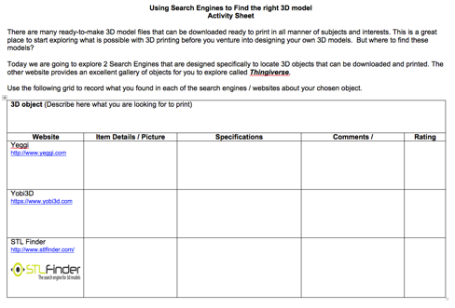 | Students will conduct a search to locate a 3D object of their choice using 3 3D seatch engines.  Students will evaluate the effectiveness of each of the search engines to successfully locate the desired object.  Students will complete the 3D Search Engine Comparison Sheet  Assessment Mode  (suggested)  Formal (worksheet completion)  Project Based (Step 1 of project)  ePortfolio (collated work)
Plenary Activity: | Create a showcase or collaborative file of the chosen 3D items. Gain a class consensus about which search engine is the most effective / useful.

