An Introduction to 3D Design with Tinkercad

Lesson Sequence
Key Concept / Learning Objective | Activities | Resources/Room Design | Assessment
An Introduction to 3D Design with Tinkercad  Suggested timeframe: 2-3 lessons | Summary: This lesson will introduce students to 3D design using a 3D software program called Tinkercad. Students will be guided through a series of lessons / tutorials of increasing complexity to introduce some of the basic skills and terminology required to confidently use the Tinkercad program. Once the designated lessons have been completed students will design their own 3D object. The nature of the object will be dependent on a range of factors including year level, previous experience of students in 3D design and the subject being used for the context of the design students must create. (i.e the 3D model may determined by a science or Mathematics topic for example).  It is expected that students will have had some lessons introducing the concept of 3D printing and what it can be used for.
Curriculum Content Covered:
KNOWLEDGE & UNDERSTANDING: Digital Systems > Digital systems have components with basic functions that may connect together to form networks which transmit data
PROCESSES PRODUCTION & SKILLS: Creating Solutions by: Investigating and Defining > Define a problem, and set of sequenced steps, with users making a decision to create a solution for a given task, Identify available resources. Producing and implementing > Select, and apply safe, procedures when using components and equipment to make solutions
GENERAL CAPABILITIES/CROSS CURRICULUM PRIORITIES: Critical and Creative Thinking, Information & Communication Technology (Investigating with ICT)
Students will:  - Understand that there are a range of programs available to help them design 3D Models  - Be introduced to Tinkercad software  - Develop a graphical representation of a 3D object using Tinkercad;  - Safely print an object using a 3D printer. | An Introduction to Tinkercad  Pre-requisites: Students should have been introduced to the concept of 3D design software and had a chance to explore 3D objects, printers and pre-designed objects in previous lessons. If this has not been done previously show video below (or similar) to introduce the idea that 3D printing is now becoming available to everyone and that we can become designers ourselves if we have the right software / tools.  https://www.youtube.com/watch?time_continue=75&v=G0EJmBoLq-g  Software to design 3D Models  Suggest to students that there are many software programs and Apps that are available to design / create 3D objects and today they will be introduced to one called Tinkercad  Introductory Video  Begin by showing the Introductory video for Tinkercad on YouTube.  Show students the Tinkercad website (see link) and demonstrate how to register an account.  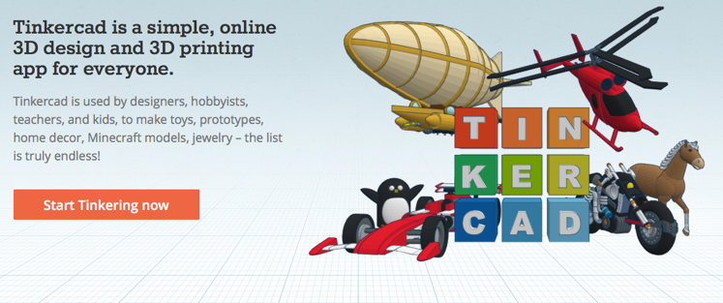  Tutorials  Once students have registered they should go the Learn module where there are a series of tutorials that will teach the basic skills required for 3D modelling. This can be done together as a class or individually with the teacher providing support as necessary.  https://www.tinkercad.com/about/learn  The number of tutorials you allow students to do in class will depend on their age, competency. access to technology and time available.  Options for the tutorials:  - Following the sequence as recommended by Tinkercad;  - Completing one project per category;  - Completing all projects before students can create their own;  - Allowing students to select projects they must complete before they can create their own or  - Specifying projects that link to a specific topic (jewellery making, inventions etc.)  Assessment and Record Keeping  Once students register an account Tinkercad keeps a record of all lessons completed and students can return to the lessons at a later date if needed.  The Assessment Sheet can also be used to monitor which tutorials have been completed.  Extension Activities  For students who complete the required tutorials earlier than other students there are a number of features in Tinkercad that they can explore:  3D Design Gallery  Within the Gallery there are a range of models that have been created by others. They could view the Gallery select ‘favourite’ 3D Models or locate models according to a specific criteria you have set.  Profile in Tinkercad  Students can explore the features and functions within their Account by selecting the icon in the top right-hand corner. They can create a profile, look for any notifications, create a new design or review the designed that they have already created. | Room Design  (suggested)  Campfire (instruction)  Watering Hole (showcase creation)  Materials:  Data projector  Tinkercad Lesson Record Sheet  Preparation  - Internet for access to Tinkercad for all students  - Students to have Tinkercad account. This could be done at the beginning of lesson but would save time if students have already created their accounts.  - Data projector for demonstration and to show videos  - Print Tinkercad Record Sheet for each student or make it available for download  Useful links:  https://www.tinkercad.com/about/learn  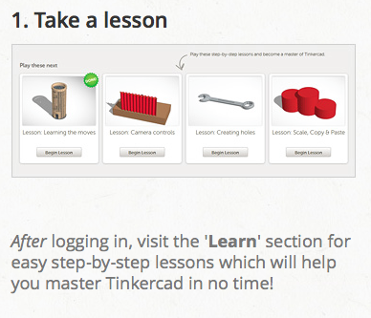  Here is a list of the categories of lessons / tutorials:  Basics  Accessories  Gadgets  Buttons  Jewellery  Miniatures  Figures  Home décor  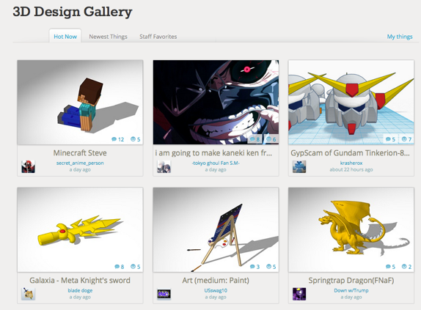  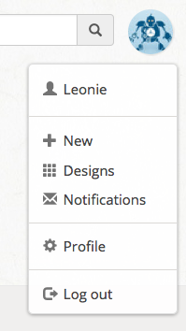  Screen capture of Drop-down menu for the Tinkercad. Students can update tier profile and create new projects from this menu | Assessment Mode  (suggested)  Formal (completion of lessons)  Project Based (in situ)  ePortfolio (collated work)  Completion of lessons / tutorials.  Records kept on Tinkercad or Record Sheets  Students evaluate thorugh emoticons how ell they did on each of the activities.  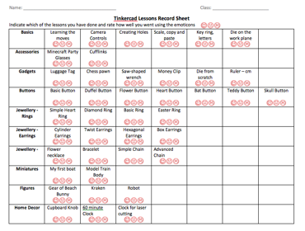  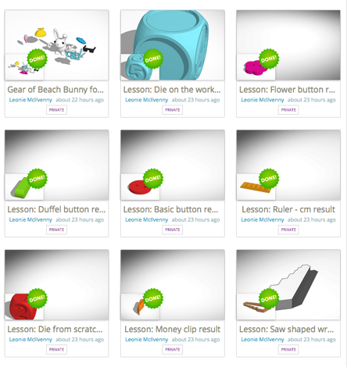  In your  Tinkercad account it will show which tutorials have been completed and recommend ones to continue with.

